**Practical No : 09**

**Aim :** Write a PHP program to demonstrate the connections to MongoDB

**Q.1) Insert**

<?php

$m=new MongoClient();

echo "Connection to Database Succesfully";

$db=$m->mydb;

echo "Database my db selected";

$collection=$db->mycol;

echo "Collection selected succesfully";

$doc=array(

"title" => "MongoDB",

"description" => "database",

"like"=>100,

"url"=>"http://www.mongo.com",

"by"=>"NoSql");

$collection->insert($doc);

echo "Document inserted succesfully";

?>

**Output :**

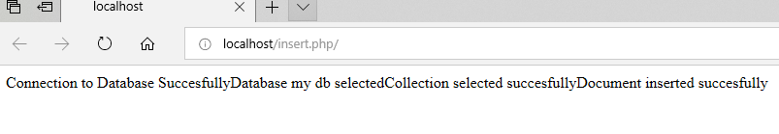

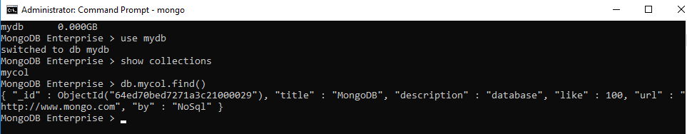

**Q.2) Retrieve**

<?php

$m=new MongoClient();

echo "Connection to Database Succesfully";

$db=$m->mydb;

echo "Database my db selected";

$collection=$db->mycol;

echo "Collection selected succesfully";

$cursor=$collection->find();

foreach ($cursor as $doc){

echo "<br>".$doc["title"]."<br>";

echo "<br>".$doc["description"]."<br>";

echo "<br>".$doc["url"]."<br>";

echo "<br>".$doc["like"]."<br>";

}

?>

**Output :**

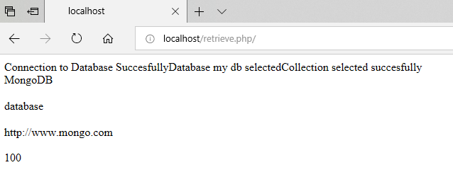

**Q.3) Update**

<?php

$m = new MongoClient();

echo "Connection to database successfully";

$db = $m->mydb;

echo "Database mydb selected";

$collection = $db->mycol;

echo "Collection selected succsessfully";

$collection->update(array("title"=>"MongoDB"),

array('$set'=>array("title"=>"MongoDB Tutorial")));

echo "Document updated successfully";

$cursor = $collection->find();

echo "Updated document";

foreach ($cursor as $document) {

echo $document["title"] . "<br>";

}

?>

**Output :**

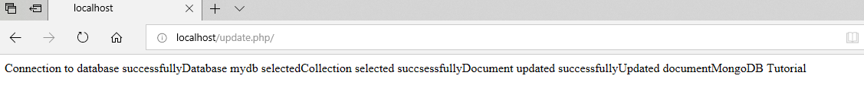



**Q.4) Delete**

<?php

$m = new MongoClient();

echo "Connection to database successfully";

$db = $m->mydb;

echo "Database mydb selected";

$collection = $db->mycol;

echo "Collection selected succsessfully";

$collection->remove(array("title"=>"MongoDB Tutorial"));

echo "Documents deleted successfully";

$cursor = $collection->find();

echo "Delete document";

foreach ($cursor as $document) {

echo $document["title"] . "\n";

}

?>

**Output :**

